# **CHAPTER 4**

# **OPTIMIZATION AND DESIGN**

## Introduction

In the previous chapter, electrical and mechanical design parameters of the selected axial flux permanent magnet generator are presented. In order to do that, mathematical design equations and related drawings are represented. These equations are important for this thesis work, as they are used in the main design algorithm code, which is written in MATLAB. Also in the previous chapter, verification of the analytical equations of the some important design parameters is given by means of finite element analysis for a sample design. For this purpose, comparison of the design equations and the finite element analysis is made in terms of air gap flux density and induced emf. It’s concluded that the results show good agreement. Therefore, these equations can be used in the optimization algorithm with high accuracy. In this chapter, optimization process of the given design will be summarized and the optimum design parameters of the proposed 5 MW AFPM generator will be determined. Firstly, evolutionary algorithms (EA) will be reviewed including the chosen genetic algorithm (GA). Then, process of the genetic algorithm based optimization method, which is used in this thesis study, will be explained in detail. Optimization of the proposed generator is constructed with MATLAB optimization toolbox. Also in this chapter, a brief information of this toolbox and used parameters in the optimization algorithm will be covered. Finally, optimum design parameters of the proposed 5 MW 12 rpm AFPM generator will be presented. These design parameters will be used in the finite element modelling and analysis in the next chapter.

## Evolutionary Algorithms (EA) and Genetic Algorithm (GA)

There exist different mathematical search algorithms and conventional methods for modern world engineering problems. However, multi-variable nonlinear problems require new methods to avoid from getting stuck into local minimums during the optimization process [1]. The main motivation of the Evolutionary Algorithms (EA) is to mimic the nature to find the optimum solutions to these problems. EA can be evaluated as a direct, stochastic and population-based search algorithm. There are three main rules of biological processes which inspire the EA based search algorithms. These processes can be summarized as follows;

* **Continuous evolution process** which occurs at the most basic level of “source-code” of living beings, i.e. chromosomes
* **Natural Selection mechanism** in which the fittest individuals in a society can have more chance to survive and have more robust offspring than those who are not fit at all.
* **Evolutionary process at reproduction** which is done by the reproduction operators such as cross-over and mutation.

EA mimics the natural selection of living beings. Fittest one in the group has more chance to survive and to breed. Individuals correspond to encoded solutions of the given problem. Every individual has a fitness value which is calculated by the objective function of the problem. Algorithm itself evaluates the “adaptive skills” of every individual according to its fitness value. Least “fit” individuals are eliminated from the population, hence more adapted and robust individuals replace the old generations. Fitness value is the only required quantitative information about the individual in EAs, contrary to other search techniques such as gradient based optimization methods, in which derivative information is needed [2], [3]. Another advantage of evolutionary search algorithm is the population based evaluation, which is a big computational advantage over the conventional search algorithms which sample one individual at a time. This population leveled optimization is more advantageous especially when working with large search spaces [4], [5]. In Fig. 4-1, a classification table of the search techniques is given.

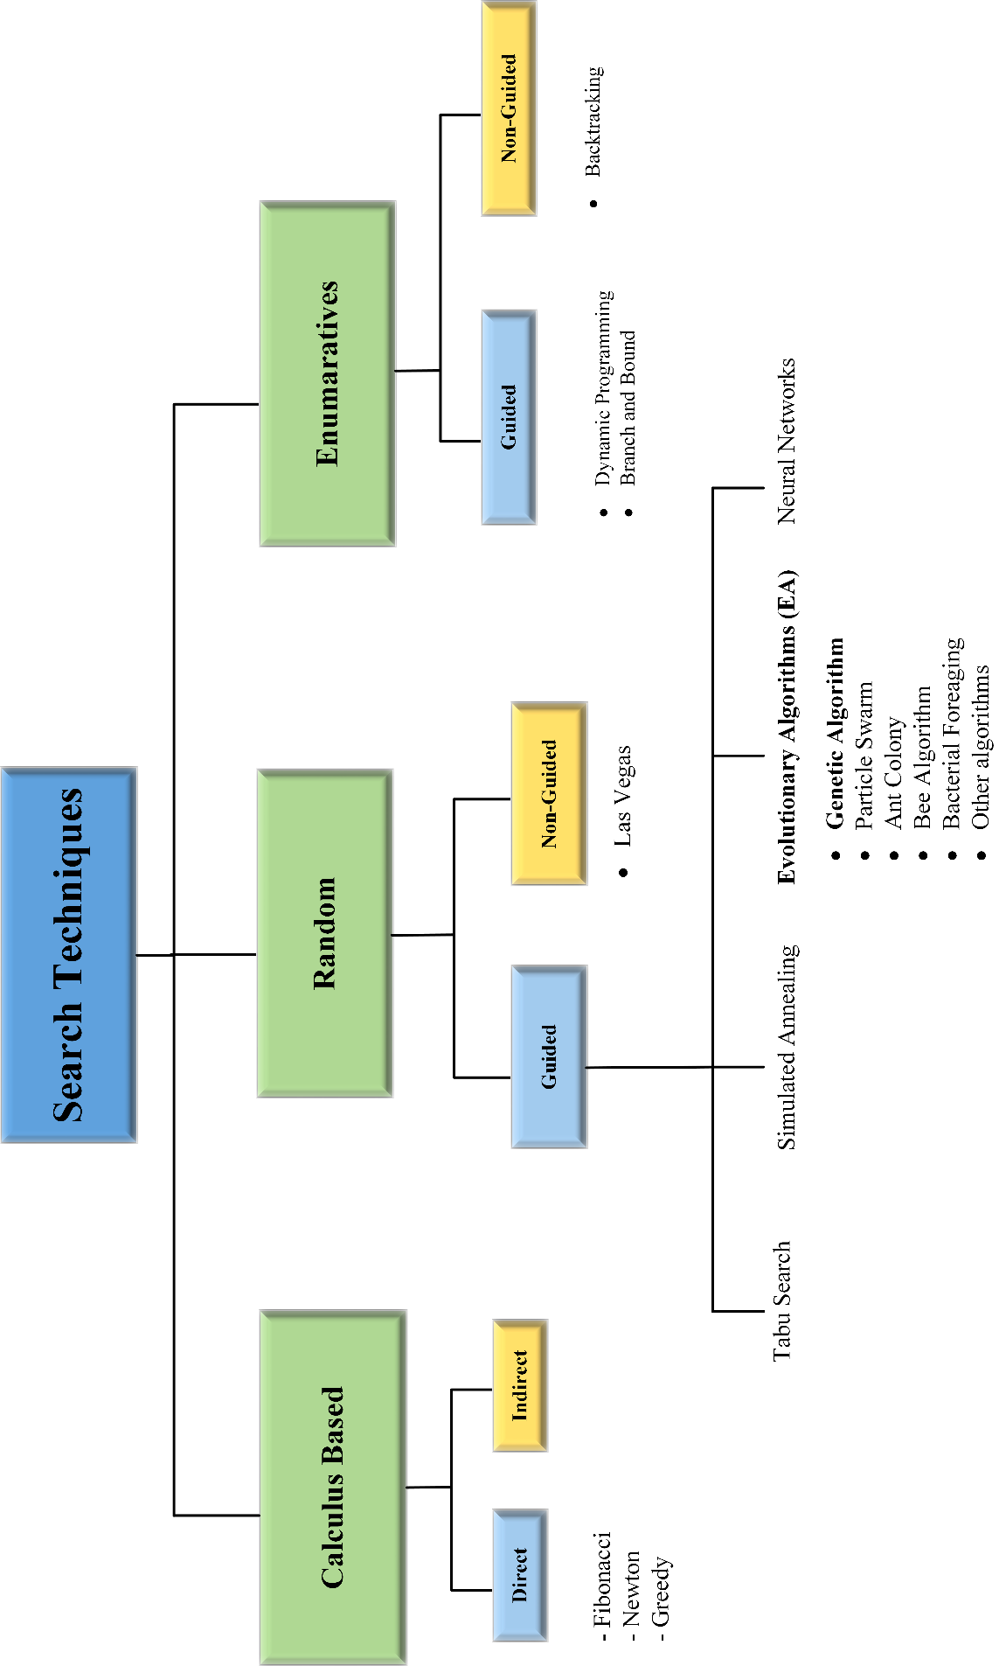

Fig. 4-1. Classification of the search techniques [1], [5], [6]

The most popular search technique among other techniques in the EA family is the genetic algorithm (GA). In this algorithm, individuals are generally represented as fixed-length bit strings as shown in Fig. 4-2 and Fig. 4-3. Different cell positions in these strings contains information which corresponds to different properties of the individual they represent [5]. Two frequently used operators during the reproduction stage of GA are cross-over and mutation operators. Various “individuals” or various “solutions” can be obtained during the optimization process by using these two operators. Working principles of cross-over and mutation operators are depicted in Fig. 4-2 and Fig. 4-3, respectively. In cross-over, data interchanges between parents around the crossover point which determined in the reproduction stage. However, in mutation, random new data is written to randomly selected locus on the selected “chromosome” or “individual”.



Fig. 4-2. Bit string cross-over operation between parent individuals [5]



Fig. 4-3. Bit string mutation operation [5]

Evolutionary algorithms start with the initial population where values of the initial variables are selected randomly by selection operators based on stochastic methods. Successive generations are created based on the selection and the reproduction principles. Population size is preserved throughout the generations. Optimization algorithm stops when termination criteria are satisfied [4], [5]. These criteria can be different conditions such as predetermined fitness value, predetermined number of successive generation or limited time.

Every problem can be solved by using EA as long as it is expressed with a proper fitness function. User should define a fitness function such that generations could converge to optimal solution. Therefore, every constraint parameter and penalty coefficient corresponding to it should exist in the fitness function maybe not equally but in a weighted form [2]. Penalty coefficients and related definitions will be covered in the following sections. Another advantage of EAs is that it can be combined with other conventional search techniques. EAs can be utilized in a parallel fashion in order to evaluate the fitness among the candidate solutions, as mentioned before. Possibility of converging local minimum is decreased due to this parallel process. Because of the high computational burden related to larger search spaces and hybridization processes, optimization techniques by using distributed computing gaining attention [5]. Also, evolutionary algorithms can easily adapt to changing environmental conditions. Therefore, it’s not necessary to restart the algorithm in case of sudden changes, contrary to as it was in the conventional search methods [1].

To sum up, evolutionary algorithms gaining popularity especially in the last two decades due to advantages aforementioned above although first attempts to use evolutionary techniques in optimization problems were made in nearly 60 years ago [4], [5]. There are two biggest key aspects of this search technique. One of is that the similarity between the nature during selection and variation stages. The other one is that it is not necessary to provide mathematical information except fitness function in order to evaluate generations of individuals [7]. Additionally, there exist a large application area of this algorithm from medical treatments to advanced engineering problems [8]. This application area seems to enlarge due to new explorations of evolutionary genetics science in biology and increased computer capacities.

## Genetic algorithms based optimization

Genetic algorithms (GA) are stochastic search techniques and exist on the subgroup of evolutionary algorithms. GA was first proposed by John Holland in 1975 with the aim of investigating the usage of natural evolutions for optimization principles [4]. The most salient feature of the GA among the other search techniques is that it doesn’t need derivative information of the related search space. This feature helps GA to avoid trapping at local minimums [8], [9]. Algorithm itself based on the three operators namely selection, crossover and mutation [4], [10]. As it was in the evolutionary algorithm case, GAs can also explore the search space in a parallel fashion. Another advantage of GA is that optimization procedure can converge to global minimum solution regardless of the starting point. Crossover and mutation definitions are same for the GA, as it was mentioned in the previous section. For an effective optimization, options of the GA such as population size, cross-over and mutation possibilities and termination criteria, should be suitably configured [11].

General flowchart of a GA is given in Fig. 4-4. However, it is useful to describe some of the technical terms about GA before continue with the flowchart.

* *Gene* is a parameter which defines the specific trait of the considered solution such as stator outer diameter, axial length or air gap flux density. This parameter is encoded in the related locus of fixed-length chromosome.
* *Chromosome* is the combined form of genes, thus representing a complete “individual”.
* *Locus* is the specific position of encoded data exist in each string of individual or solution.
* *Fitness* is the measure of suitability of a generated solution for the given optimization problem. This numeric value is used by the GA when evaluating and selecting the best individual from the candidate solutions. Because of this reason GA optimizations are usually mentioned with the term “survival of the fittest”. Fitness function of the optimization problem should be constructed carefully in order to achieve the optimum design parameters of the selected AFPM topology.
* *Selection* used in GA is mainly based on stochastic processes and natural similarities. However, there are different selection methods for application such as roulette wheel selection and tournament selection [3], [5].
* *Population* can be considered as a group of individuals in one generation. Larger sizes of population leads to longer solution times but larger search spaces.
* *Generation* is the set of individuals employed in one cycle of optimization. As the evaluated number of generations are increased, more fit solution candidates will be created by the GA.
* *Elitism* is related to best individuals which are preserved and directly pass to next generation without any gene manipulation. If number of elite is too much generations don’t change much and diversity decreases. If number of elites is low then optimization lasts longer to converge to global minimum because of large diversity.
* *Independent variable* is an optimization parameter which is changed by the GA at every iteration. For example in this thesis work, there are 15 different independent variables in the optimization process of the proposed AFPM.
* *Penalty function* is a concept that is used to convert a constrained optimization to an unconstrained optimization problem. Main idea in this concept is that to “penalize” the individuals with additional higher fitness values, whose solution parameters violate the limits of predetermined constraints.



Fig. 4-4. General flowchart of a GA optimization [11]

## MATLAB GA Toolbox Implementation

## MATLAB Toolbox and Configurations

In this thesis, optimization procedure is implemented by MATLAB optimization toolbox. For this purpose, three different codes, which include the necessary design equations described in the previous chapter, are written and tested in the MATLAB environment. These codes are mainly performs following actions;

* Optimization main handling and saving performance parameters
* Iterative loop for required multi-speed operation calculation
* Main design calculation of the generator for a given set of variables

In our design, objective function is constructed based on the cost of the proposed generator. Therefore, GA tries to minimize the total cost of the generator by using different mass combinations of different materials used in the generator. Details of the objective function and constants will be given in the following subsections. In this subsection, details and the configurations of optimization procedure will be described. Configuration parameters used in the optimization process are given in Table 4-1.

Table 4-1. Configuration parameters of the MATLAB optimization toolbox

|  |  |
| --- | --- |
| Solver | Genetic Algorithm-ga |
| Number of variables | 15 |
| Population Size | 100 |
| Fitness Scaling | Rank |
| Selection Function | Stochastic Uniform |
| Elite Count | 1 |
| Crossover Fraction | 0.9 |
| Mutation | Gaussian with Scale/Shrink |
| Crossover Function | Scattered |
| Number of Generation | 200 |
| Stall Generations | 50 |
| Stall tolerance | 1x10-6 |

As seen from Table 4-1, there are 15 different independent variables used in our design optimization. Selection is realized via stochastic uniform function based on the fitness value. In this function, individuals have probability to be selected by the GA inversely proportional to their rank value. Therefore, individuals with lower rank value have more chance to be selected. Cross-over fraction determines the rate of the individual in a population (except the elite ones) which are subjected to cross-over operation during the reproduction stage. Higher rates of this parameters results in higher diversity despite longer solution times. Cross-over is realized via scattered function. In this function first a random vector, which consists of random binary numbers, is created. Then this random vector is compared with the selected parent vectors in bit-wise. Variables of the offspring individual created according to this comparison. If binary number is 1 then “gene” is taken from first parent otherwise second parent gives the related gene from its corresponding locus [12].

In our optimization process two different termination criterions are defined as it can be seen on Table 4-1. Optimization process will stop either when the total number of generation is equal to 200 or when 50 successive generations occur with average change in fitness function is less than “Stall tolerance”. GA in MATLAB searches for the optimum set of parameters between the predetermined lower and upper boundaries. Independent variables of the optimization can be seen in Table 4-2 with their definitions and related boundaries.

Air gap clearance *g* is segregated from this table because it is taken as constant. As it will be mentioned in the following sections, constant value of air gap is taken as 10 mm for our proposed generator and stator outer diameter is limited to 10 meters by optimization. Main reasons of this selection are production limitations and “1/1000 air gap diameter ratio” convention [13], [14] which will be explained in the following sections. Current density optimization range is determined based on the thermal considerations which were mentioned in the previous chapter. Magnet/steel width ratio, pitch ratio and fill factor ranges are selected based on the literature and conventional practices [15], [16].

## Flowchart and Objective function

In this thesis work, considered AFPM design problem can be described as a non-linear optimization problem. Nonlinear constrained optimization problems are generally expressed as follows [9], [17],

Minimize *F(x)* (4-1)

  (4-2)

  (4-3)

 (4-4)

Table 4-2. Independent variables of the optimization

|  |  |  |  |  |
| --- | --- | --- | --- | --- |
| **Variable Vector-x** | **Variable Definition** | **Lower boundary** | **Upper boundary** | **Unit** |
| x(1) | Mean radius () | 4 | 5 | m |
| x(2) | Current Density (*J)* | 1 | 7 | A/mm2 |
| x(3) | Outer limb thickness | 0.03 | 0.045 | m |
| x(4) | Inner limb thickness | 0.02 | 0.03 | m |
| x(5) | Steel web thickness *lc* | 0.02 | 0.03 | m |
| x(6) | Magnet/steel width ratio | 0.7 | 0.8 | - |
| x(7) | Number of turns *Nt* | 40 | 90 | Turn |
| x(8) | Number of poles *Np* | 200 | 260 | Pole |
| x(9) | Number of branches | 4 | 6 | Branch |
| x(10) | Height of the winding | 0.03 | 0.045 | m |
| x(11) | Pitch ratio | 0.3 | 0.4 | - |
| x(12) | Fill factor *kfill* | 0.6 | 0.7 | - |
| x(13) | Height of the magnet *hm* | 0.01 | 0.02 | m |
| x(14) | Length of the magnet *l*m | 0.25 | 0.3 | m |
| x(15) | Number of parallel stacks | 3 | 6 | - |

where *F(x)* corresponds to objective function and *x* represents the set of the independent variables. Conditions given in the Eq. (4-2) and Eq. (4-3) are defined as inequality constraints and equality constraints to which objective function is subjected. As mentioned before, variable set is chosen between lower and upper bound intervals which are predetermined before GA optimization process. These boundaries are shown in Eq. (4-4). In this study, main objective function is constructed based on the cost of the designed generator and can be expressed as follows,

 (4-5)

where  , ,  and  are cost of steel, cost of copper, cost of permanent magnet and cost of structure, respectively. Coefficient of “1.2” is multiplied by the total material cost due to add the approximately 20% labor cost effect to the material cost. Cost components of the main objective function given in Eq. (4-5), can be calculated as follows,

 (4-6)

 (4-7)

 (4-8)

 (4-9)

Penalty functions are defined and used in order to convert our constrained optimization problem to an unconstrained optimization problem. Therefore, it is not necessary to define equality and inequality constraints in MATLAB optimization toolbox. Penalty functions are used such that an additional value, which is to be added to original objective function, is calculated proportional to measure of violation of a constraint [5], [9]. In this study, seven different constraints are added in a form of penalty functions to the main objective function. Details of the constraints will be given in the following subsections. Resulting objective function in which the penalty functions added form is given as follows,

 (4-10)

where  and  are the penalty function for ith constraint and penalty coefficient for ith penalty function, respectively. Details of the penalty functions will be given in the following sections. Income function  is utilized in order to include the effects of energy ratio and time probability of the wind in the total energy production for a proposed generator. This function is calculated as follows,

 (4-11)

where  is the net output power from the generator,  is the electricity price per kWh sold by the WPP and taken as 7.3 $ in this study [18],  is the capacity factor for proposed wind turbine and taken as 0.9 and finally  is the time probability of the related wind speed.

Flowchart of the used optimization algorithm in this study is given in Fig.4-5. First, an initial population is created by the MATLAB optimization tool based on the configurations given in Table 4-1. Then, the reference wind speed data is taken from wind-speed data table. Current density is initially assigned as the half of the upper limit of the current density, namely Jmax/2 . Then this current density value, rpm value and demanded power are used together with the created random independent variables in order to calculate the design parameters of the generator. After the first design calculation, current density value is adjusted according to efficiency of the design and reference current density values calculated for steady state and short circuit fault conditions. Then a final design calculation is made for the current rpm interval. This calculations are repeated for all 9 operating conditions for the same design to evaluate performance of the generator at different wind speeds. Cost function is calculated according to objective function defined in Eq. (4-10) by considering the energy ratios of the different wind speed intervals given in the reference wind-speed data table. Then, termination criteria are checked in order to stop the optimization process. This procedures are repeated until termination criteria are satisfied and the optimal design is achieved. Details of the aforementioned variable speed conditions will be covered in the next section.

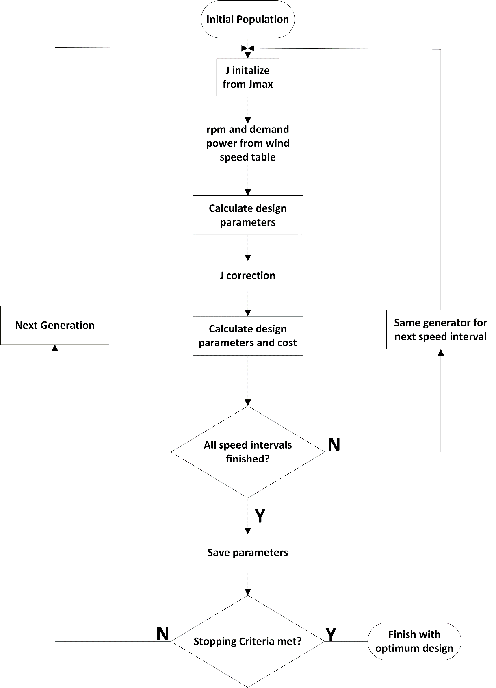

Fig. 4-5. Optimization flowchart

## Operating Conditions of the Generator

If a design calculations of a wind turbine generator are only based on the rated speed and power output conditions, probably manufactured design will not be efficient as much as it was in the design stage. This is due to intermittent nature of the wind. Therefore, variable speed operation must be taken into account and different speed distributions of the turbine must be evaluated during the optimization. In this study, design optimization of the proposed AFPM generator is carried under 9 different wind speed conditions with respect to given time probabilistic densities. For this purpose, wind speed measurements data of a sample WPP, located in Çanakkale/Turkey, is used. In Fig. 4-6, time probabilities of the wind speed intervals are calculated based on the one year period of measurement data. As it can be seen from this figure, wind speed density plot shows a typical Weibull distribution.

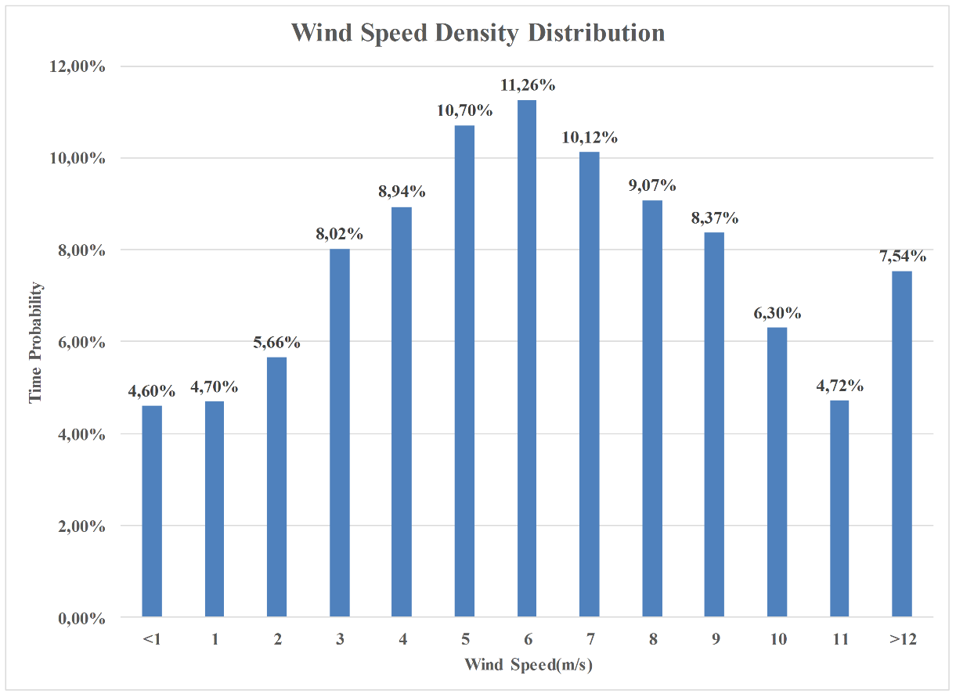

Fig. 4-6. Wind speed density distribution from measurement data

Different properties of the wind speed distribution and a 5MW “reference” wind turbine [19] characteristics under these wind conditions, which are desired to be reached by the optimized AFPM generator of this study, are tabulated in Table 4-3.

Table 4-3. Wind speed distributions and reference generator ratings

|  |  |  |  |  |  |
| --- | --- | --- | --- | --- | --- |
| Wind Speed | Average Speed (rpm) | Average Torque (kNm) | Output Power (kW) | Time Probability | Energy Ratio |
| 4 m/s | 1 | 187.5 | 195 | 31,92% | 4,09% |
| 5 m/s | 1 | 4038,5 | 420 | 10,70% | 2,95% |
| 6 m/s | 2.9 | 2606,1 | 786 | 11,26% | 5,81% |
| 7 m/s | 4.8 | 2596,2 | 1296 | 10,12% | 8,61% |
| 8 m/s | 6.7 | 2788,5 | 1943 | 9,07% | 11,57% |
| 9 m/s | 8.6 | 3017,7 | 2699 | 8,37% | 14,84% |
| 10 m/s | 10.5 | 3193,2 | 3487 | 6,30% | 14,43% |
| 11 m/s | 12 | 3344,6 | 4174 | 4,72% | 12,94% |
| >12 m/s (Rated) | 12 | 4006,4 | 5000 | 7,54% | 24,76% |
| Weighted Average (time) | 4.7 | 2154,9 | 1522,6 | 100,00% | 100,00% |

## Constants and Constraints

## Constants

Although there are 15 independent variables in our optimization, some other variables and parameters can be taken as constant based on the assumptions and experiences in order to simplify the optimization handling and to avoid large and complex search spaces. Conceptual constants aforementioned above are given in Table 4-4 for our proposed AFPM.

Air gap clearance value is determined based on the cost comparison of designs with different air gap values. Besides, selected 10 mm of air gap clearance value is consistent with the assumption of “air gap clearance could be nearly 1/1000 of the air gap diameter” principle of electrical machine design [13], [14]. In addition to this principle, 10 mm air gap is also selected for comply the production limitations. Current density is optimized during the optimization process with other independent variables. However, final value of this variable is determined by the iterative design loops in the multi-speed code, instead of a random number assigned by the GA.

Table 4-4. Conceptual optimization constants of the proposed AFPM generator

|  |  |
| --- | --- |
| **Constant** | **Value** |
| Air gap clearance | 10 mm |
| Number of phases | 3 |
| Ambient temperature | 20o C |
| Current Density | Forced air cooling with 7 A/mm2 @100oC |
| Power factor angle | 0o (cosφ=1) |
| Coil pitch/Pole pitch | 4/3 |

In order to do this, predetermined current density value (7 A/mm2 for this design) is assumed for reference operational temperature at 100oC [20]–[22]. Operating temperature and final value of the current density are calculated according to this current density reference-based iterative loops in the design code. Thermal considerations about the design were expressed in the previous chapter. Although thermal network is neglected, high efficiency rate is forced by the optimization algorithm in this study. Power factor is assumed as unity in our design. This assumption is based on a vector controlled power electronic converter which connects the proposed AFPM generator to grid [23]. Ratio of “4/3” between the coil pitch and the pole pitch is selected as it is advantageous rather than other ratios in terms of induced emf magnitude. This magnitude variation was mentioned and depicted in Fig.3-2 in Chapter-3.

In addition to conceptual constants described above, there are number of constants related to material characteristics such as mass density and remanence flux density. These constants used in the optimization are given in Table 4-5.

Table 4-5. Material constants of the proposed AFPM generator

|  |  |  |
| --- | --- | --- |
| **Constant** | **Definition** | **Value** |
|  | Temperature coefficient | 3.9x10-3 OC-1 |
|  | Resistivity coefficient | 1.7x10-8 ohm.m |
|  | Height of the band | 0.01 m |
|  | Width of the band | 0.04 m |
|  | N50 grade PM remanent flux density [24] | 1.4 T |
|  | PM relative permeability | 1.05 |
|  | Steel relative permeability | 750 |
|  | Winding-steel web distance | 0.015 m |
|  | Leakage coefficient | 0.95 |
|  | Epoxy thickness | 1 mm |
|  | Mass density of steel | 7850 kg/m3 |
|  | Mass density of copper | 8960 kg/m3 |
|  | Mass density of PM | 7500 kg/m3 |
|  | Mass density of epoxy | 1150 kg/m3 |
|  | Shaft outer radius | 0.3 m |
|  | Shaft inner radius | 0.1 m |
|  | Unit cost of steel[25] | 3 $/kg |
|  | Unit cost of PM[25] | 80 $/kg |
|  | Unit cost of copper[25] | 10 $/kg |
|  | Unit cost of epoxy[7] | * 1. $/kg |

## Constraints

Constraint in an optimization problem mainly defines the limitations which are not supposed to be violated. This necessity can be due to physical properties of the materials or due to designer’s priorities. In this study, independent variables are allowed to vary between lower and upper bounds of the predetermined search space. However, sometimes selection of these variables by GA can result in improper consequences. Therefore this kind of faulty selections must be corrected by the optimization programming [9]. These corrections occur at every loop of design calculation of the generator. This type of corrections in this study can be listed as follows,

* Number of turns (), number of poles (), number of parallel branches () and number of stacks () are selected as integer variables.
* In addition to that, number of poles are rounded nearest integer which is multiple of four, in order to get a suitable number of series connected coils. This relationship can be expressed as follows;

 (4-18)

where  represents the number of coils per phase and calculated as follows for 3-phase system,

 (4-19)

We know that, there is a (4/3) ratio between number of poles and number of coils:

 (4-20)

Therefore, number of series connected coils can be calculated as follows,

 (4-21)

In the design code, number of parallel branches  selected so that  division can be calculated as an integer value.

* Winding thickness/coil pitch ratio is also controlled in case any improper former dimensions such as negative former pitch. Pitch of the coil former is calculated by using Eq. (3-85) in the previous chapter.
* Outer core limbs must be always thicker than inner core limbs in order to withstand single-sided magnetic forces. Considerations about deflection were mentioned in the previous chapter.
* Magnet/steel width ratio should be selected in proper limits in order utilize the magnets efficiently. In our design this parameter is allowed to vary between 0.7 and 0.8. In the previous chapter, effects of having large ratios of this parameter were mentioned.

Controls described until here were generally related to geometrical design parameters of the proposed generator and can be corrected via adjusting limits of the search space. Hence these can be categorized as search space manipulations. Other than these corrections, there are some other parameters which should be checked if any resulting parameter value of the designed generator violates the safety/necessity margins or not. These kind of parameters are generally named as “constraint” in a optimization process. User/designer can keep this kind of parameters under control by using penalty functions. As described before, penalty functions are used to convert constrained functions to unconstrained functions by assigning additional penalty values, which are relatively large with respect to normal fitness values, to related objective function in the optimization. Hence individuals which are penalized with these penalty functions have large fitness values and then are finally eliminated from successive generations. By this way, optimization changes the search direction to where individuals satisfy all the constraints [9], [11], [17]. Details of the penalty functions and penalty coefficients will be given in the following subsection.

In our design optimization, 7 different constraints are included in objective function via proper penalty functions. Order of these seven penalty functions and related penalty coefficients are given in Table 4-6. These penalty functions are used in the main objective function which was given by Eq. (4-10).

Table 4-6. Objective function penalty table

|  |  |  |  |
| --- | --- | --- | --- |
| **Penalty Function** | **Constraint** | **Penalty Coefficient** | **Coefficient Value** |
|  | Efficiency |  | =5x104  =3x107 |
|  | Deflection |  | 105 |
|  | Axial length |  | 105 |
|  | Outer diameter |  | 108 |
|  | Temperature |  | 105 |
|  | Power |  | =0.1  =1 |
|  | Voltage |  | 106 |

These penalty functions are calculated as follows,

* Efficiency () is controlled at every design loops and individuals with efficiency values lower than 95% , are penalized. Efficiency constraint is controlled by the Eq. (4-11) given below.

 (4-11)

* Another constraint is related to C-core deflection (). Due to magnetic attraction forces between magnets, C shaped cores are inclined to be deflected and close the air gap. If this deflection rate with respect to air gap clearance excess 10%, individual which has this much deflected core, is penalized. Ratio of deflection constraint is controlled by the Eq. (4-12) given below.

 (4-12)

* Another constraint is related to axial length () and it’s very important. Because one of the salient advantages of proposed AFPM is shorter axial length [26]. For this purpose, individuals who has axial length higher than 5 meters, are penalized. Axial length constraint is controlled by the Eq. (4-13) given below.

 (4-13)

* Stator outer diameter () is another important parameter of the generator, especially when the nacelle volume is limited. Therefore, individuals with stator outer diameters above 10 meter, are also penalized. Outer diameter constraint is controlled by the Eq. (4-14) given below.

 (4-14)

* Operating temperature () is another important design parameter related to efficiency. In this design optimization, individuals which has operating temperature higher than 100o C, are penalized. In addition to temperature constraint, efficiency constraint also guarantees the thermal limits by assigning high efficiency penalties to candidate individuals with high copper losses. Temperature constraint is controlled by the Eq. (4-15) given below.

 (4-15)

* As mentioned before, in every optimization loop GA algorithm tries to determine the design parameters of the AFPM which gives output power of 5MW at 12 rpm rated speed. For this purpose, designed machine is operated at every speed interval which defined earlier in Table 4-3 and tries to reach the output power of every specific operating speed reference. Individual which misses these power levels, is penalized with a penalty function. Power constraint is controlled by the Eq. (4-16) given below.

 (4-16)

* Final constraint employed in this optimization work is related to electrical rating of the proposed generator. Rms value of the voltage per phase () is kept under controlled via suitable penalty function such that line-to-line rms voltage level can’t excess the 690 V, which is a common voltage level among commercial wind turbine generators [27], [28]. Proper voltage level selection is important since the output voltage level which is too high or too low can cause higher power electronic converter costs. Voltage constraint is controlled by the Eq. (4-17) given below.

 (4-17)

As it can be seen from calculations, response of the penalty functions can be adjusted via penalty coefficients at different order of magnitude and via different measure of violation such as absolute difference or square of the absolute difference. Hence optimization will converge to an area of search space such that chosen set of independent variables don’t violate the constraints. As a result, penalty coefficients are chosen very large to satisfy all the constraints strictly. Therefore, a small violence of any constraint will be penalized with a large fitness value [9].

## Optimized 5MW AFPM Generator

Optimized independent variables of the proposed AFPM generator at rated conditions of 5 MW, 12 rpm, are presented in Table 4-7. Note that optimization algorithm converges to increased number of parallel stack in order to conform penalty constraints of outer diameter and power level. By this way, amount of permanent magnet is increased. However, this type of parallel stacked configuration gives better fault handling ability to our proposed generator, as it was mentioned in previous chapters. Other design parameters of the optimized AFPM generator can be calculated by using the design equations given in Chapter-3.

Table 4-7. Optimized generator independent variables at 12 rpm/5MW

|  |  |
| --- | --- |
| **Parameter** | **Value** |
| Mean radius- | 4.66 m |
| Speed | 12 rpm |
| Number of poles- *Np* | 216 |
| Number of parallel stacks- | 6 |
| Outer limb thickness- | 33.3 mm |
| Inner limb thickness- | 21.9 mm |
| Steel web thickness-*lc* | 22 mm |
| Number of turns- *Nt* | 44 |
| Current density-*J* | 2.45 A/mm2 |
| Number of branch- | 6 |
| Height of the winding- *hw* | 44 mm |
| Winding thickness/Coil pitch ratio- | 0.38 |
| Magnet/Steel width ratio- | 0.76 |
| Fill factor-*kfill* | 0.69 |
| Height of the magnet-*h*m | 18.8 mm |
| Length of the magnet- *l*m | 285 mm |

Best fitness values of the optimization process through the 200 generations are plotted in the graph given in Fig. 4-7. As it can be seen from this figure, best fitness value of the optimization converged to 4.8x106. In the optimization algorithm, every candidate individual is evaluated for nine wind speed conditions. Fitness function is obtained by summing all cost values for these speed conditions. Therefore, it can be said that fitness function itself not obviously shows exact cost of the proposed generator. Instead, it shows how suitable and low cost solution it becomes throughout the generations. Optimization considers not only initial material cost but also power generation income and selects suitable parameters among the search space. Therefore, more material cost and mass can be preferred for the sake of a better revenue.

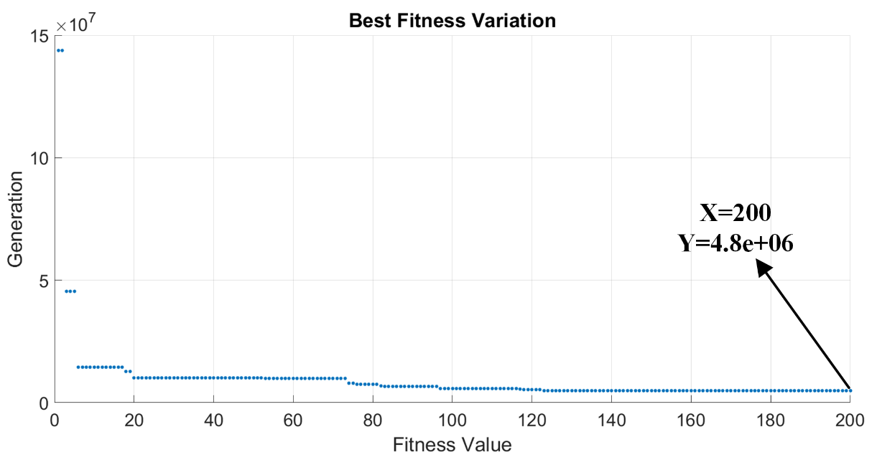

Fig. 4-7. Best fitness variation

Fitness values of all individuals regardless of mean values, are depicted in Fig. 4-8. As it can be seen from this figure, cost of the considered generator showing a decreasing trend as the optimization procedure continues. At the end of the iterations, optimization converged to best fitness value of 4.8x106.

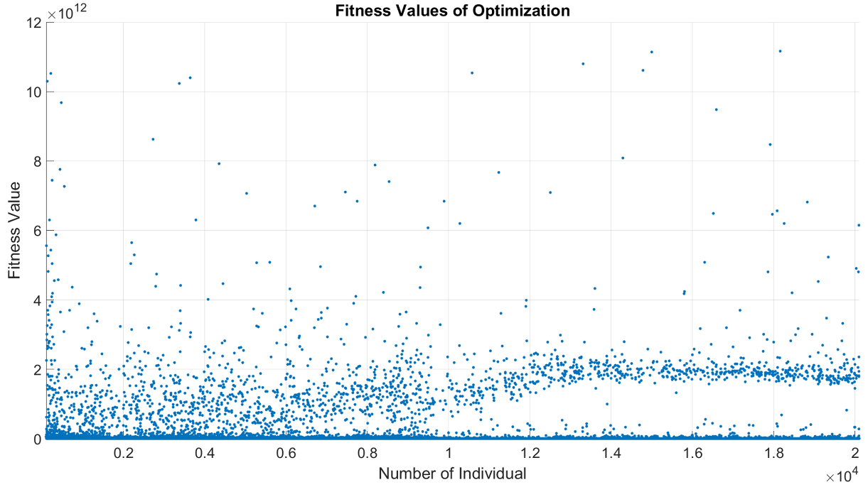

Fig. 4-8. Fitness distribution of the optimization individuals according to iterations

Performance ratings of the optimized generator at different wind speeds are given in Table 4-8.

Table 4-8. Optimized generator performance ratings

|  |  |  |  |  |  |  |  |  |
| --- | --- | --- | --- | --- | --- | --- | --- | --- |
| **Wind Speed** | **Rpm** | **(A/mm2)** | **(V)** | **(A)** | **Desired Power**  **(kW)** | **Input Power**  **(kW)** | **Output Power**  **(kW)** | **Efficiency**  **(%)** |
| 4 m/s | 1 | 1.35 | 25.5 | 397.0 | 195 | 244 | 182 | 74.6 |
| 5 m/s | 1 | 2.08 | 20.3 | 610.5 | 420 | 371 | 223 | 60.0 |
| 6 m/s | 2.9 | 1.68 | 87.8 | 491.1 | 786 | 874 | 776 | 88.8 |
| 7 m/s | 4.8 | 1.60 | 153.1 | 469.2 | 1296 | 1386 | 1293 | 93.2 |
| 8 m/s | 6.7 | 1.70 | 216.8 | 497.6 | 1943 | 2052 | 1942 | 94.6 |
| 9 m/s | 8.6 | 1.83 | 280 | 535.6 | 2699 | 2834 | 2699 | 95.2 |
| 10 m/s | 10.5 | 1.93 | 343.3 | 564.6 | 3487 | 3647 | 3489 | 95.6 |
| 11 m/s | 12 | 2.02 | 392.9 | 590.5 | 4174 | 4357 | 4177 | 95.8 |
| 12 m/s | 12 | 2.45 | 386.9 | 716.8 | 5000 | 5240 | 4992 | 95.3 |

As it can be seen from performance ratings table above, optimized generator can supply 4.99 MW of electrical output power at 12 rpm, which is only 0.01 MW below the aimed output power of 5 MW with an efficieny of 95%. This small power constraint violation can be neglected since all other contraint parameters are conformed by the optimization. In Fig. 4-9, whole view of the proposed AFPM generator is given. In this figure structural support parts are not shown.

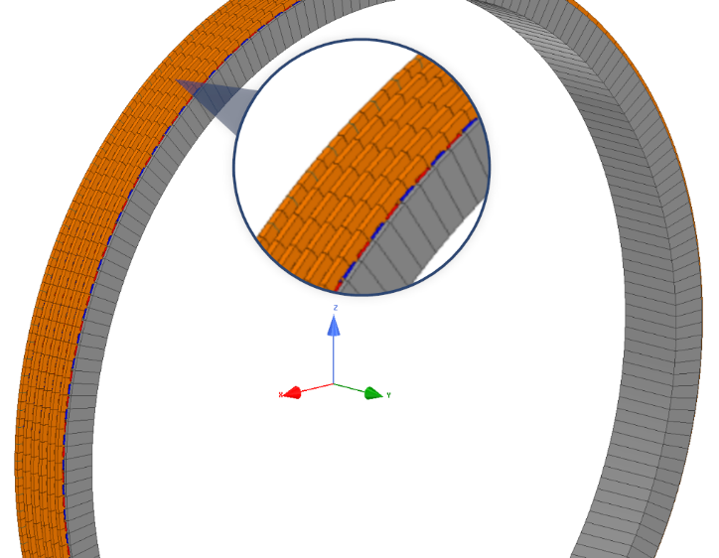

Fig. 4-9. Proposed AFPM generator whole machine view without structural parts

In Fig.4-10, mass components of the optimized 5MW 12 rpm AFPM generator is given. In Fig.4-11, material cost components of the optimized 5MW 12 rpm AFPM generator is given. As it can be seen from graphs, there is not a linear relationship between mass and cost distributions of materials used in the proposed generator. It has been concluded that structural steel mass is the dominant part of the total mass while permanent magnet cost constitutes the dominant part of the total cost of the generator.

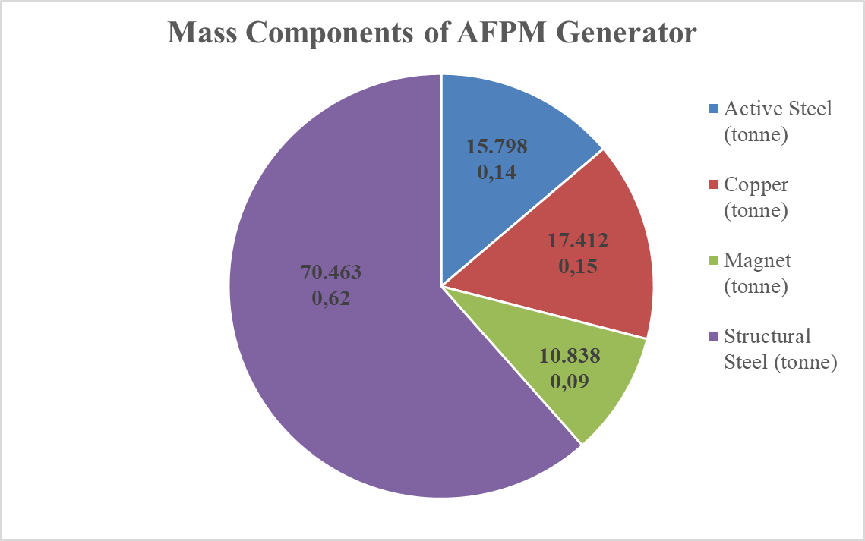

Fig. 4-10. Mass components of the optimized AFPM generator

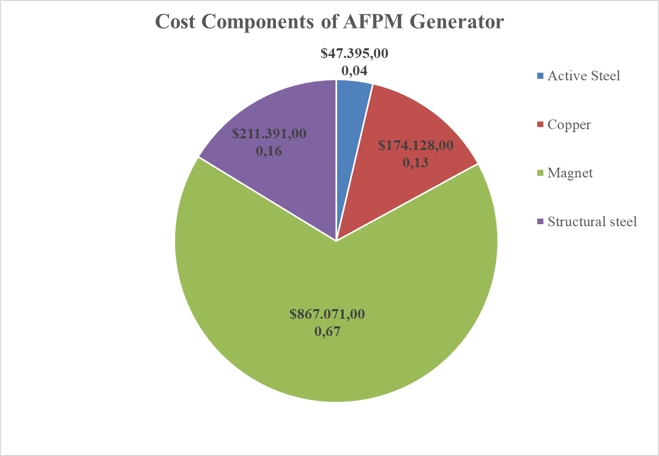

Fig. 4-11. Material cost components of the optimized AFPM generator

## Results

This chapter mainly focused on the optimization procedure and optimized generator parameters. First, general overview of the EA is given including the selected GA optimization. This algorithm is chosen in this thesis work because of its derivative-free approach and application simplicity. GA is the most prominent algorithm in the EA family. GA mimics the nature when reproducing and evaluating the candidate individuals for the proposed AFPM. This algorithm is implemented by using MATLAB genetic algorithm optimization toolbox. For this purpose, few scripts are written which includes the necessary design equations of the selected AFPM and other optimization handling algorithm. In this study, optimization procedure is carried under 9 different wind speed conditions in order to get a more realistic design. Wind speed data is taken from a real field based measurement values of a sample WPP. Algorithm calculated the design parameters of the proposed AFPM generator based on a power generation reference of a commercial 5MW PMSG wind turbine under aforementioned wind conditions. In addition, algorithm also considers the wind speed time probabilistic and related generation incomes. Details of the MATLAB optimization toolbox configurations and used algorithm flowcharts are given in the related subsections.

Seven different penalty functions are used in order to convert our constrained optimization problem to an unconstrained problem. In this study, objective function is constructed based on the cost of the proposed AFPM generator. 15 different independent variables are used in the optimization problem. Air gap is not optimized in this study in order to avoid very large search spaces and long convergence times. Instead, air gap value is taken as constant as 10 mm as it is comply with the conventional machine design practices and production challenges. Axial stack number of the generator is allowed to change during the optimization. Therefore, algorithm converges to best solutions so that resulting generator can be heavier but more cost-effective considering the generation incomes. Details of the constants, independent variables, objective function and penalty functions are given in the related subsections. According to optimization results, most salient features of the proposed AFPM generator in this thesis is tabulated in Table 4-9. Other details of the design parameters can be found by using mentioned MATLAB scripts which are designed for this thesis work.

Details of the reference wind speed table and performance parameters of the proposed AFPM generator under these wind conditions are given in related subsection. Optimized independent variables of the proposed 5MW/12 rpm AFPM design and fitness evolution tables are presented and discussed. Finally, mass components and material cost components of the proposed generator are investigated. According to results of these components, structural steel is the most dominant (about 62%) mass component while it is the less dominant (about 16%) in terms of material cost. Permanent magnet (PM) is the most dominant (about 67%) cost component while it is the least dominant (about %9) mass component. Since optimization is based on the cost of the design, algorithm converged to heavier and larger design solution. However, mass of the most expensive component, namely PMs, is minimized. More detailed graphs of mass and cost distributions of the proposed design is given in the related subsections. Optimized parameters are very important because they will be used in the finite element modelling and verification of the proposed generator in the next chapter.

Table 4-9. The most salient features of the proposed AFPM generator at 12 rpm

|  |  |
| --- | --- |
| **Feature** | **Value** |
| Mean radius | 4.66 m |
| Stator outer diameter | 9.9 m |
| Rated speed | 12 rpm |
| Air gap | 10 mm |
| Number of poles | 216 |
| Number of turns | 44 |
| Axial length | 0.98 m |
| Number of axial stack | 6 |
| Voltage per phase (rms) | 386.9 V |
| Induced emf per-phase (rms) | 412.42 V |
| Current per phase | 716.8 A |
| Total copper loss | 206.4 kW |
| Total eddy loss | 42 kW |
| Net output power | 4992 kW |
| Efficiency | 95.2% |
| Air gap flux density (fundamental-peak) | 0.51 T |
| Air gap flux density (flat-top) | 0.45 T |
| Phase reactance | 0.12 Ω |
| Phase resistance | 0.022 Ω |
| Power factor | 1 |
| Temperature | 29.8o C |
| Shaft outer radius | 0.3 m |
| Shaft inner radius | 0.1 m |
| Total mass | 114.7 tonne |
| Total cost (including labor) | 1.56 M$ |
| Total Electricity Generation (annual) | 11.73 GWh |
| Total Generation Income (annual) | 85.66 M$ |

**References**

[1] Umut Güvengir, “ONLINE APPLICATION OF SHEM TO GRID-CONNECTED INVERTERS WITH VARIABLE DC LINK VOLTAGE BY PARTICLE SWARM OPTIMIZATION,” 2014.

[2] O. Keysan, A. S. McDonald, and M. Mueller, “Integrated Design and Optimization of a Direct Drive Axial Flux Permanent Magnet Generator for a Tidal Turbine,” in *International Conference on Renewable Energies and Power Quality - ICREPQ’10*, 2010.

[3] K. M. Leung, “GENETIC ALGORITHMS,” 2003. [Online]. Available: http://cis.poly.edu/~mleung/CS4744/f04/ch06/GA3.pdf. [Accessed: 16-Aug-2017].

[4] M. Mitchell, “An introduction to genetic algorithms,” *Comput. Math. with Appl.*, vol. 32, no. 6, p. 133, 1996.

[5] S. N. Sivanandam and S. N. Deepa, *Introduction to genetic algorithms*. 2008.

[6] J. M. PEÑA, “Heuristic Optimization Introduction and Simple Heuristics.” [Online]. Available: http://mat.uab.cat/~alseda/MasterOpt/IntroHO.pdf. [Accessed: 16-Aug-2017].

[7] P. Virtiˇ and M. Vraˇ, “Design of an Axial Flux Permanent Magnet Synchronous Machine Using Analytical Method and Evolutionary Optimization,” *IEEE Trans. Energy Convers.*, vol. 31, no. 1, pp. 150–158, 2016.

[8] G. Papa, B. Korousic-Seljak, B. Benedicic, and T. Kmecl, “Universal motor efficiency improvement using evolutionary optimization,” *IEEE Trans. Ind. Electron.*, vol. 50, no. 3, pp. 602–611, Jun. 2003.

[9] R. Zeinali, “DESIGN AND OPTIMZIATION OF HIGH TORQUE DENSITY GENERATOR,” *MS thesis*, no. September, 2016.

[10] M. Łukaniszyn, M. JagieŁa, and R. Wróbel, “Optimization of permanent magnet shape for minimum cogging torque using a genetic algorithm,” *IEEE Trans. Magn.*, vol. 40, no. 2 II, pp. 1228–1231, 2004.

[11] J. Azzouzi, N. A. Karim, G. Barakat, and B. Dakyo, “Axial flux PM synchronous generator design optimization: robustness test of the genetic algorithm approach,” *2005 Eur. Conf. Power Electron. Appl.*, vol. 9, p. 10 pp.-pp.P.10, 2005.

[12] “MATLAB Documentation.” [Online]. Available: https://www.mathworks.com/help/matlab/. [Accessed: 08-Aug-2017].

[13] J. N. Stander, G. Venter, and M. J. Kamper, “Review of direct-drive radial flux wind turbine generator mechanical design,” *Wind Energy*, vol. 15, no. 3, pp. 459–472, Apr. 2012.

[14] H. Li and Z. Chen, “Structural mass in direct-drive permanent magnet electrical generators,” *Renew. Power Gener. IET*, vol. 2, no. 1, pp. 3–15, 2007.

[15] J. F. Gieras and M. Wing, *Permanent Magnet Motor Technology: design and applications*, vol. 113. 2002.

[16] F. G. Capponi, G. De Donato, G. A. Rivellini, and F. Caricchi, “Fractional-Slot Concentrated-Winding Axial-Flux Permanent-Magnet Machine With Tooth-Wound Coils,” vol. 48, no. 2, pp. 630–641, 2012.

[17] T. Veflingstad, “Axial flux machines with super high torque density or super high efficiency,” no. July, p. 2014, 2014.

[18] “Rüzgar Santralleri (RES) YEKDEM Geliri.” [Online]. Available: http://www.enerjiatlasi.com/epias/res-yekdem-geliri. [Accessed: 23-Oct-2017].

[19] Gamesa, “Gamesa G128-5 MW Catalog.” [Online]. Available: http://www.gamesacorp.com/recursos/doc/productos-servicios/aerogeneradores/catalogo-g10x-45mw-eng.pdf. [Accessed: 12-Oct-2017].

[20] a. Parviainen, M. Niemela, J. Pyrhonen, and J. Mantere, “Performance comparison between low-speed axial-flux and radial-flux permanent-magnet machines including mechanical constraints,” *IEEE Int. Conf. Electr. Mach. Drives, 2005.*, pp. 1695–1702, 2005.

[21] A. Parviainen, *Design of Axial-Flux Permanent-Magnet Low-Speed Machines and Performance Comparison between Radial-Flux and Axial-Flux Machines*. 2005.

[22] J. Braid, A. van Zyl, and C. Landy, “Design, analysis and development of a multistage axial-flux permanent magnet synchronous machine,” *Africon Conf. Africa, 2002. IEEE AFRICON. 6th*, vol. 2, pp. 675–680, 2002.

[23] S. X. Liu, S. Li, and J. He, “Unity Power Factor Control of a Direct-Driven Permanent Magnet Synchronous Wind-Power Generator Based on Three-Level Converter,” *Adv. Mater. Res.*, vol. 347–353, no. m, pp. 2227–2230, Oct. 2011.

[24] “Sintered Neodymium Iron Boron (NdFeB) Magnets.” [Online]. Available: http://www.eclipsemagnetics.com/media/wysiwyg/brochures/neodymium_grades_data.pdf. [Accessed: 09-Aug-2017].

[25] A. Rokke, “Doctoral thesis GENERATORS FOR MARINE GENERATORS FOR MARINE,” 2017.

[26] D. J. Bang, H. Polinder, G. Shrestha, and J. A. Ferreira, “Promising direct-drive generator system for large wind turbines,” *EPE J. (European Power Electron. Drives Journal)*, vol. 18, no. 3, pp. 7–13, 2008.

[27] “Nordex Delta Generation Brochure.” [Online]. Available: http://www.nordex-online.com/fileadmin/MEDIA/Produktinfos/EN/Nordex_Delta_Broschuere_en.pdf. [Accessed: 09-Aug-2017].

[28] “Generators for wind power Proven generators – reliable power.” [Online]. Available: http://new.abb.com/docs/default-source/ewea-doc/abb-brochure-generators-for-wind-power.pdf?sfvrsn=2. [Accessed: 09-Aug-2017].